Clinician Excellence Award

SUMMARY

Create a process to enable students to formally recognize clinicians who exemplify choosing wisely / high-value care values in their practice.

PURPOSE

To reinforce a culture of high-value care in clinical learning environments through formally recognizing clinicians who exemplify and promote these values in their practice and in their mentorship of students/trainees.

WHY IMPLEMENT

To encourage dialogue amongst students/trainees and clinicians regarding high-value care, patient safety, patient experience, and evidence-based practices. To promote collegiality between students/trainees and mentors. To bridge the current gap between principles learned "in the classroom” related to high-value care and actual practices (“the hidden curriculum”) in clinical learning environments.

STEPS FOR IMPLEMENTATION

- Discuss your desire to implement this award at your school with your STARS faculty mentor – include past STARS in your planning/implementation efforts;
- Reach out to September Wallingford, Deputy Director at Costs of Care (september@costsofcare.org) with the # of Choosing Wisely lapel pins you will need;
- Plan an informational session prior to students starting their clerkships to present the award program, criteria, and data gathering tool associated with the award:
  - Nomination Criteria:
- any clinician (physician, physician assistant, nurse practitioner, nurse, pharmacist, physical therapist, social worker, etc.) within your medical school network;
- exemplifies and promotes the principles of high-value care (eg Choosing Wisely) to students/trainees, including but not limited to:
  - facilitates dialogue with students/trainees regarding high-value care, which may take the form of discussion on how and when to order tests, perform procedures, and/or prescribe medications that are both cost-efficient and supported by evidence as being truly necessary;
  - teaches students/trainees to encourage patients to ask questions and to include patients in conversations surrounding costs of care;
  - encourages students/trainees to include a value/safety component in SOAP presentations;
  - includes Choosing Wisely guidelines and resources on rounds and aids students/trainees in the implementation of these guidelines/resources.

- Create a simple Google form (see “Nomination Criteria/Form” below) and send an email with the link before the end of each clerkship block to ask students for their nominations;
- Plan a final awards ceremony with your Student Affairs faculty/STARS faculty mentor to hand out the award and Choosing Wisely lapel pins at the end of the year;
- Send congratulatory emails to clinicians to let them know of their nomination for this award (see “Other Resources” below), as well as details for the awards ceremony to follow.

HELPFUL RESOURCES

Nomination Criteria/Form (courtesy of Dell Medical School, UT-Austin):

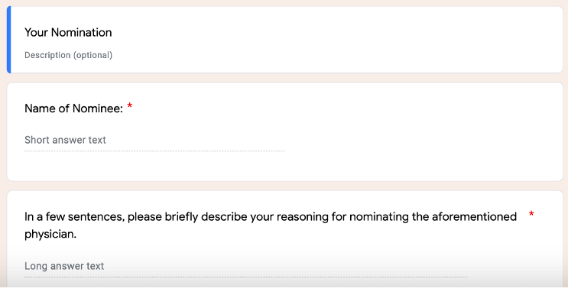
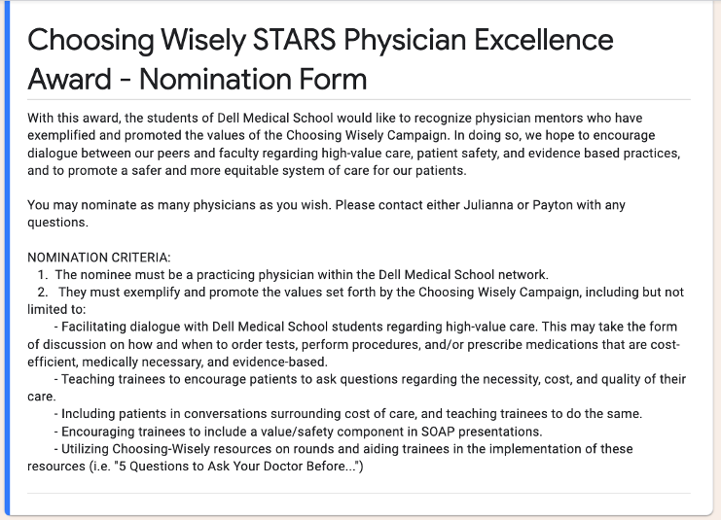

Other Resources – Congratulatory Email (courtesy of Dell Medical School, UT-Austin):

Dear [insert clinician name here],

Congratulations! We are writing to inform you that you have been nominated by your students for the Choosing Wisely STARS Clinician Excellence Award. The Choosing Wisely STARS program aims to catalyze grassroots, student-led initiatives to advance health care value in medical education. As [your school] STARS students, we asked our medical student peers to nominate clinicians who serve as exemplars in promoting and teaching the principles of value-based healthcare. Your nomination signifies your commitment to encouraging dialogue amongst students and clinicians regarding high-value care, patient safety, and evidence-based practices.

One or more students have nominated you for this award and notably said [specific criteria met, as indicated by nominating student(s)].

We invite you to attend an awards ceremony, [specific ceremony details], where we will recognize the individuals who will receive a Choosing Wisely STARS lapel pin.

Thank you for your commitment to the ideals set forth by the Choosing Wisely Campaign, and for continuing to shape our healthcare environment into one that is continuing to strive for healthcare that is more equitable, patient-centered, and value based. Your leadership in this endeavor has not gone unnoticed.

Sincerely,

[Student name(s)]
[Year] Choosing Wisely STARS
[Medical School]

BEST PRACTICES & LESSONS LEARNED

Best Practices

- Integrate with a school-wide program for public award ceremony to highlight importance of this award (e.g. at Dell Med, it is part of the annual “Dell Med Educational Innovation, Research & Awards Symposium” attended by the Dean and faculty); however, would not let this be a barrier to implementation if you are unable to coordinate with a schoolwide program;
- Best when the award is led and given by the students, with the support and potential “co-signing” of the STARS faculty mentor or other local faculty champions;
- Consider copying the awardee’s Department Chair and/or other supervisors on the “congratulatory email”.

Lessons Learned

- Frequent reminders for the class about this award are needed to generate nominations throughout the year;
- STARS currently on clerkship rotations are effective leaders for the program and can frequently remind their classmates to submit nominations at the end of every clinical rotation throughout the year.

IMPACT STATEMENTS

“Make sure there is a culture at your medical school in which your peers are fired up about CW and what we are doing! Educating and exciting them will make the reception of this award much more positive.” – Julianna Khoury-Martin (Dell Medical School, Class of 2022)

“I'm deeply appreciative of being selected for this award. I share with the STARS the belief that the small steps we take as educators and learners will continue to add up to make a tangible difference to all.” – Dr. Menaka Jayasundera, a 2021 Choosing Wisely STARS Physician Excellence Award Winner

CHAMPIONS



Julianna Khoury-Martin, MD/MBA, is a first-generation resident physician from El Paso, Texas and pediatrician at Texas Children’s Hospital in the L.E.A.D advocacy program. She is passionate about high-value care, social determinants of health, and the comprehensive care of underserved children.



Payton Hughes, MD/MBA, was born and raised in Dallas, Texas and is a resident OB-GYN at John Peter Smith Hospital. She is passionate about patient advocacy, health equity, and, of course, value-based care.

For questions about the Clinician Excellence Award:
please email september@costsofcare.org

